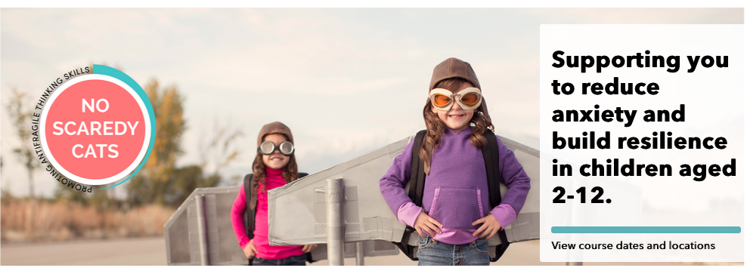

Supporting you to reduce anxiety and build resilience in children aged 2-12.
View course dates and locations

No Scaredy Cats

ONE-DAY PROFESSIONAL DEVELOPMENT WORKSHOP
The No Scaredy Cats™ workshop is based on three underlying perspectives: first, by having an understanding of how anxiety develops, teachers, educators, community and family support workers can assist parents to counter its progress in children. Second, teachers, educators, community and family support workers can assist parents take a preventative role in the development of anxiety problems in 2-12 year olds. Third, there are practical steps parents can take to develop resilience thinking skills in 2-12 year olds.
Courses available all around Australia.

Expected Learning Outcomes
- Greater understanding of the problem of increasing levels of anxiety in children and some strategies for its treatment.
- An opportunity to become a certified No Scaredy Cats™ parent educator.
Active PD points apply.

What’s Included
- A note-taking manual for use at the workshop.
- Meals and refreshments.
- PD points for accreditation with your respective professional associations.
- A certificate of completion for the workshop.
- An opportunity to become a certified No Scaredy Cats™ parent educator.

Lesson Framework
- Coverage of how some misguided policies are making parents and children more anxious.
- The brain,including how the pre-frontal middle cortex and the amygdala operate, and where fear and anxiety originates.
- Commonly misused phrases and cognitive distortions used by children and their peers.
- A helicopter view of what risks we can allow and which require us to keep children safe.
- ‘Traps and trip wires’: what to do when a child’s amygdala starts to play-up.
- Memorable strengthening sayings, questioning strategies and mindfulness exercises.
- Scenarios and worksheets.

Certification
To become a certified parent educator, you’ll be provided with additional resources needed in order to present to parents. This ensures that our product is only being taught at the highest quality. There are several benefits in becoming certified:
Certification is renewed each year. certification is $69 per person for the first year, thereafter there will be a $49 membership fee charged annually to remain a certified parent educator.
What comes with certification
- Listing on our website as a certified No Scaredy Cats™ parent educator.
- Access to additional resources such as relevant articles and tips on presenting.
- A comprehensive set of session guidelines.
- Digital practitioner materials, including a slideshow for parent presentations and teaching films.
- An annual licence to teach the program to parents.
- Resources for marketing.
- A comprehensive set of session guidelines.

